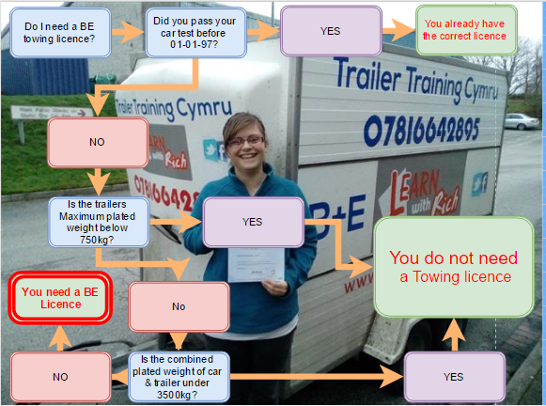
Remember to use the weights from the car & trailers weight plates or the V5 section F1
DO NOT use kerb weight, loaded weight weigh bridge weights.
You cannot tow a heavy type trailer even if empty unless you have a BE towing licence.

